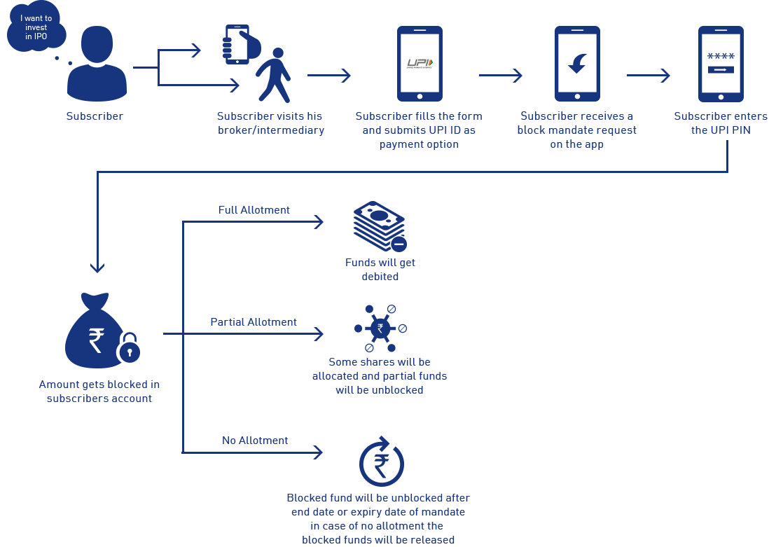

Advantages/Value add:
- Enjoy the instant fund transfer experience of UPI while subscribing for IPO
- Instant mandate creation ensures real time application submission
- Customer support for transaction related issues

Sr. No. | UPI Apps live on IPO | Handle
1 | BHIM Baroda Pay (only Android) | @BARODAMPAY
2 | BHIM RBL Pay (Android & iOS) | @rbl
3 | BHIM (android & iOS) | @upi
4 | BHIM ALLBANK UPI (only Android) | @allbank
5 | BHIM AUPay (Android & iOS) | @aubank
6 | BHIM Axis Pay (only android) | @axisbank
7 | BHIM IndusPay (only Android) | @indus
8 | BHIM Lotza UPI (only Android) | @federal
9 | BHIM SBIPay (only android) | @sbi
10 | BHIM YES PAY (only Android) | @yesbank
11 | Citi Mobile (android & iOS) | @citi & @citigold
12 | DigiBank - DBS (Android & iOS) | @dbs
13 | Freecharge (Android & iOS) | @freecharge
14 | Google Pay (android & iOS) | @okhdfcbank, @okaxis , @oksbi, @okicici
15 | HSBC Simply Pay (android & iOS) | @hsbc
16 | iMobile by ICICI Bank (android users) | @icici
17 | Kotak Mobile Banking App (Android) | @kotak
18 | Paytm (Android & IOS) | @paytm
19 | Phone-Pe (android & iOS) | @ybl
20 | SIB Mirror+ (only Android) | @sib

Sr. No. | Sponsor Banks live on IPO
1 | Axis Bank Limited
2 | HDFC BANK
3 | ICICI Bank
4 | Kotak Mahindra Bank Limited
5 | State Bank of India

Sr. No. | SCSBs eligible to act as Issuer Bank (Customer Bank)
1 | Allahabad Bank
2 | Andhra Bank
3 | Axis Bank
4 | Bandhan Bank
5 | Bank of Baroda
6 | Bank of India
7 | Bank of Maharashtra
8 | Canara Bank
9 | Central Bank of India.
10 | Citibank N.A
11 | City Union Bank
12 | Corporation Bank
13 | DBS Bank India Limited
14 | DCB Bank
15 | Dhanlaxmi Bank Limited
16 | GP Parsik Sahakari Bank Limited
17 | HDFC Bank Ltd.
18 | HSBC Bank
19 | ICICI Bank
20 | IDBI Bank Limited
21 | IDFC FIRST Bank
22 | Indian Bank
23 | Indian Overseas Bank
24 | Indusind Bank
25 | Janata Sahakari Bank Ltd
26 | Karnataka Bank Limited
27 | Karur Vysya Bank Limited
28 | Kotak Mahindra Bank
29 | Nutan Nagarik Sahakari Bank Ltd.
30 | Oriental Bank of Commerce
31 | Punjab & Sind Bank
32 | Punjab National Bank
33 | Rajkot Nagarik Sahakari Bank Ltd.
34 | RBL BANK
35 | Saraswat Co-operative Bank Limited
36 | South Indian Bank
37 | Standard Chartered Bank
38 | State Bank of India
39 | SVC Co-operative Bank Limited
40 | Syndicate Bank
41 | Tamilnad Mercantile Bank
42 | The Ahmedabad Mercantile Co-operative Bank Limited
43 | The Catholic Syrian Bank Limited
44 | The Federal Bank Limited
45 | The Kalupur Commercial Co-operative Bank Ltd.
46 | The Lakshmi Vilas Bank Limited
47 | The Mehsana Urban Co-operative Bank Limited
48 | The Surat People's Co-op Bank Ltd.
49 | TJSB Sahakari Bank Limited
50 | UCO Bank
51 | Union Bank of India
52 | United Bank of India

